**The INTERNATIONAL CONFERENCE**

On the 100th Anniversary

**of**

THE INSTITUTE OF PEDAGOGY KUL JP II

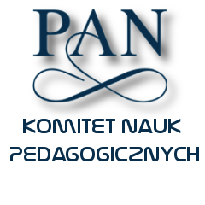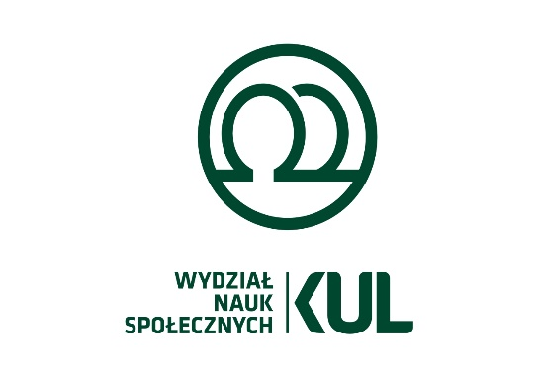

THE INTERNATIONAL SCIENTIFIC CONFERENCE

**UNDER THE PATRONAGE OF**

**THE COMMITTEE ON EDUCATIONAL SCIENCES AND HUMANITIES PAN**

**,, *Between universality and originality***

***of the Polish pedagogical thought*”**

**22-23 October 2019**

**the John Paul II Catholic University of Lublin, Poland**

**IMPORTANT INFORMATION**

The conference will be held on **22-23 October 2019** on the theme: ***Between universality and originality of the Polish pedagogical thought****.* The conference will be devoted to the analysis of tradition, role, condition, specificity and profile of the Polish pedagogical thought. In the light of the 100th anniversary of the creation of scientific structures of pedagogy in the Republic of Poland, the organizers intend to indicate the main research orientations in the practice of pedagogy in Poland, extended by the opinions of our foreign guests on this subject.

We plan to focus the conference on the following thematic blocks: ***1) philosophical pedagogy and philosophies of education, theory and history of education; 2) humanistic concepts of education, pedagogy of culture and humanistic pedagogy; 3) existential concepts of education and pedagogy of existence (relations, meetings and dialogue); 4) social pedagogy and social work; 5) pedagogy of religion, Christian pedagogy and Catholic pedagogy.***

Nonetheless, the organizers are open to any other proposals. On behalf of the Institute of Pedagogy and University Authorities, you are very welcome to participate in the celebration of the 100th anniversary of the academic activity of the Institute of Pedagogy.

We aim to discuss and reflect upon the research implementation of the above mentioned areas from the philosophical and anthropological, humanistic and cultural, social and social, existential, religious and philosophical point of view.

**The objectives of the conference:**

1. Exchanging of views and undertaking a debate on the main areas of contemporary pedagogical research in Poland and Europe.

2. Indicating of the main methodological approaches in the practice of pedagogy and their characteristics.

3. Presenting the possibilities of interdisciplinary dialogue between individual areas of pedagogical research.

4. Discussing concrete areas of pedagogical research - in their universality and specificity.

We will be pleased to host you in Lublin at the Jon Paul II Catholic University of Lublin. We plan to publish post-conference materials. Presented and submitted contents will undergo reviews. The conference fee is PLN 200, and PLN 100 for PhD students. Students can participate in the poster session.

We kindly ask you to register for the conference and submit the title of your presentation before 10th of October 2019 on the attached form.

A detailed program of the Conference will be prepared based on the submitted topics of presentations and send out after 10th of October 2019. We plan to organize plenary sessions with panel discussions are planned.

The Conference is addressed to academics, researchers, scientific and didactic staff, graduates of pedagogy, doctoral students as well as practitioners, teachers, educators, therapists, representatives of educational and social NGOs.

*On behalf of the Organizing Committee of the 100th Anniversary Conference:*

**Dyrektor Instytutu Pedagogiki KUL**



***Ks. prof. dr hab. Marian Nowak***

**IMPORTANT DATES AND REQUIREMENTS**

|  |  |
| --- | --- |
| Deadline: **10.10.2019** - registration of participation and sending the proposal of presentation (presentation, short note, participation in discussion, etc.) together with reservation of accommodation and meals (on the attached form to instped@kul.pl) on the attached form by e-mail or standard correspondence.  Further information and hotel proposals are included in the attached form. Completed forms should be sent to: **General Pedagogy Unit (Katedra Pedagogiki Ogólnej KUL) Institute of Pedagogy, the John Paul II Catholic University of Lublin, Al. Racławickie 14; 20-950 LUBLIN or by e-mail to: pedog@kul.pl; or instped@kul.pl; marian.nowak@kul.pl**  The detailed program of the conference will be sent **after 10th of October 2019.** |  |

**Conference Venue: the John Paul II Catholic University of Lublin,**

**Al. Racławickie 14; 20-950 LUBLIN;**

**Tel.** 81/445-35-38

**The Honorary Committee:**

**Members of the Committee of Pedagogical Sciences of the Polish Academy of Sciences PAN**

**The Scientific Committee:**

To be completed

**The Organizing Committee of the Conference :**

ks. prof. dr hab. Marian Nowak; ks. dr hab. Kazimierz Pierzchała, prof. KUL; Dr Piotr Magier; ks. dr Marek Jeziorański; dr Katarzyna Braun; dr Agnieszka Linca-Ćwikła, dr Magdalena Parzyszek; dr Aleksandra Borowicz; dr Renata Kołodziejczyk;

**The conference office members**: dr Piotr Magier; ks. Dr Marek Jeziorański,

ks. mgr Dariusz Konopko, mgr Angelika Lenart

**Additional contact details:**

**Sekretariat Instytutu Pedagogiki KUL**

**Al. Racławickie 14**

**20-950 LUBLIN**

**tel./fax.: (081) 5322082; (081)4759332; 609754598**

**e-mail:**

**<konferencjajubileuszowa@gmail.com>**